 **PRIVATE room dinner menu**

From the kitchen of Chef Barak Aharoni

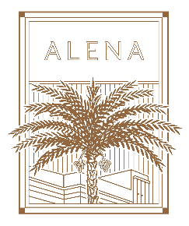

**appetizers**

Served with Fresh rye bread baskets, olive oil

Quinoa salad, edamame, pecans & green apple

Iceberg Salad – Goat's cheese, pecans, dried blueberries & vinaigrette

Fish tartare

Beef carpaccio, pecorino & balsamic vinegar

Cabbage parcels stuffed with Basmati rice, black raisins with labaneh & herbs

**main dishes**(Individual Selection)

Beef fillet with grilled onion & aromatic peppery jus

Spaghetti Arrabbiata (spicy)

Catch of the day, served with cherry tomatoes, Kalamata olives & oregano

Grilled chicken with preserved lemon, rosemary, Kalamata olives & kale

Seasonal risotto & Parmesan

**side dishes**

Green salad

Pomme purée

French fries

**desserts**

(Please choose two of them)

Chocolate nemesis

Lemon pie

Barak`s bread pudding

Panna cotta

**BEVERAGES**

Acqua Panna & San Pellegrino

Pots of filter coffee & tea selection

price: 400 nis + vat per person (boardroom&PDR)

price: 550 nis + vat per person (conservatory&tower garden)