PRIVATE room breakfast menu

From the kitchen of Chef Barak Aharoni

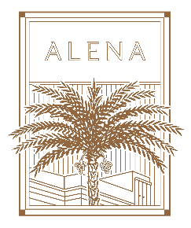

|  |
| --- |
| All dishes are served in multiples to the center of the table.  **SAVOURY BAKED GOODS**  An assortment of freshly baked artisan breads & brioche  Spinach & cheese filo pastry loaf  Cheese filo pastry loaf  **CHEF’S SELECTIONS**  Cherry tomato, Kalamata olive & radish salad  Chef’s seasonal sliced salad  Norwegian smoked salmon slices  Labaneh  Hard goat’s cheese  Mediterranean olive selection  **EGG DISHES**  Eggs Benedict(with bacon) or Eggs Florentine(with spinach) or Eggs Royal (with smoked salmon)  Traditional shakshuka (served in iron pans)  Scrambled free-range eggs  **SWEET DISHES & BAKED GOODS**  Fresh seasonal fruit platters  Brownies  **BEVERAGES**  Freshly squeezed orange and carrot juice  Pots of filter coffee and tea selection  Acqua Panna & San Pellegrino  price: 145 nis + vat per person (boardroom&PDR)  price: 240 nis + vat per person (conservatory&tower garden) |